Name: _________________ Y**ear 9 Chemistry Investigation 2015** Due date: ________________

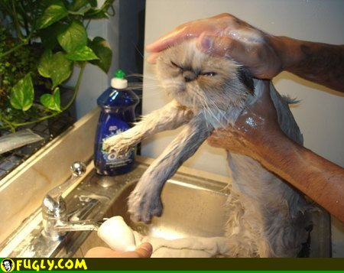

You will be provided with the following selection of shampoos:

⬩ Diluted Palmolive shampoo for normal hair

⬩ Diluted Palmolive shampoo for coloured hair

⬩ Diluted Palmolive shampoo for dry hair

⬩ Diluted Garnier Fructis shampoo for normal hair

⬩ Diluted Garnier Fructis shampoo for coloured hair

⬩ Diluted Garnier Fructis shampoo for dry hair

⬩ Diluted Organic Care shampoo for normal hair

⬩ Diluted Organic Care shampoo for coloured hair

⬩ Diluted Organic Care shampoo for dry hair

Your task is design and conduct a controlled scientific investigation to answer:

**Is the pH of a shampoo related to the type of hair for which it is designed?**

🞟 Note that there are three hair types covered in the shampoos supplied, normal, dry and coloured. There are also three brands for each type to choose from. You are NOT comparing the brands.

🞟 The designing and conducting of the experiment will be done in groups.

🞟 The write up of the investigation is to be done individually.

🞟 Your group will need to work out how to control the variables so it is a fair test, how to test the pH of the shampoo and how to record the results.

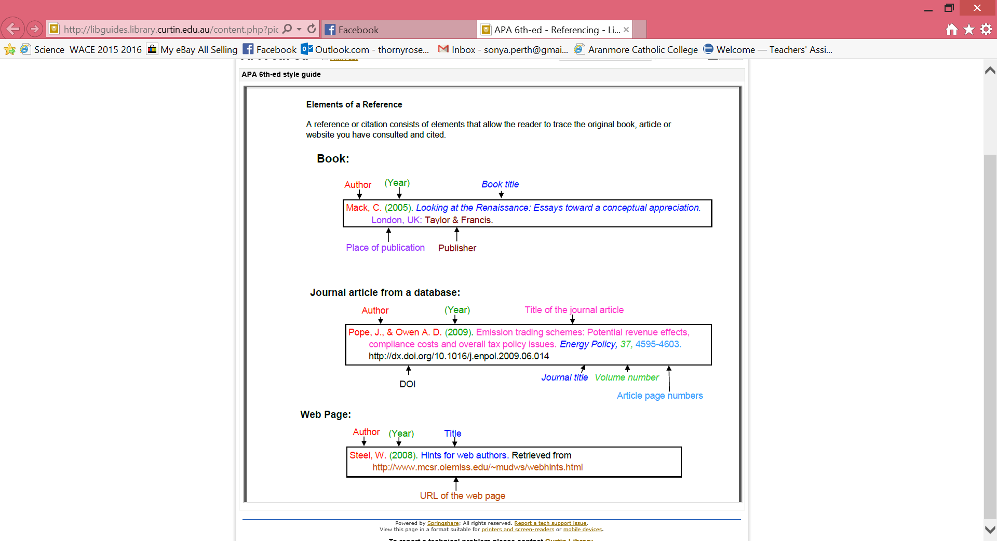**Plagiarism**

You must write in your own words not copy sentences word for word from another student or another source.

Plagiarising = instant zero on assignment and you will have to re-do it.

**Assessment policy**

Have sick note/legitimate reason from parent = new negotiated due date.

Assignment not submitted on due date and no sick note from parents = -20% mark

Assignment not submitted on new negotiated due date = -40% mark

+ Letter home to parents.

+ Must attend academic completion to complete assignment.

**OR**

Submit assignment to student services before academic completion date and academic completion not necessary.

Academic completion not attended = zero on assignment + Saturday detention.

**If you know that you cannot submit your assignment on the due date, let your teacher know BEFORE the due date (email them if you are not in school) or just email them your assignment the night before.**

|  |  |  |  |
| --- | --- | --- | --- |
| **Part**  *These should form subheadings in your work* | **Details** | **Available**  **mark** | **Your**  **mark** |
| **Title** | Explains what the investigation is about:  NOT ‘Chemistry Investigation’ | 1 |  |
| **Aim** | Why are you doing this experiment? What do you want to find out? | 1 |  |
| **Introduction** | Include background information that people need to know to understand your investigation, e.g. what is the purpose of shampoo, what is hair/scalp’s usual pH, what is the difference between normal, dry and coloured hair? | 2 |  |
| **Hypothesis** | Predictive statement including both independent and dependent variables.  Correctly worded (does not use ‘I’, ‘we’ or ‘maybe’). | 2 |  |
| **Independent Variable** | The variable I change (‘I’ for independent). When you change the independent variable the variable you are measuring (the dependent variable) will probably change too. | 1 |  |
| **Dependent Variable** | The variable you are measuring. Any change in this variable depends on what you do to the independent variable. | 1 |  |
| **Controlled Variables** | All the things you keep the same to make it a fair test.  List a minimum of two controlled variables. | 2 |  |
| **Materials** | Complete.  Written in a list.  Is specific - e.g. 25g of salt or 3 x 250ml beakers. | 2 |  |
| **Method** | Is written in numbered step-by-step.  Written in past tense (the water was poured into the beaker).  Complete.  Includes labelled diagrams (in lead pencil and neat).  Explain how reliable results are achieved (trials/replicates? How did you control your controlled variables?) | 1  1  1  2  2 |  |
| **Results** | Drawn neatly in pencil and using a ruler.  Includes the headings and units of measurement.  Includes all the data collected during the experiment. | 1  1  1 |  |
| **Graph** | Includes title, labels on each axis, correct units, regular spacing and legend for each line graph.  Use a ruler, do it in lead pencil and make it neat. | 5 |  |
| **Discussion** | What do your results show? Use numbers to describe.  Describe at least one mistake/error that occurred.  Explain how this mistake/error affected the results.  Explain how this mistake/error could be avoided. | 4 |  |
| **Conclusion** | Explain the trend (or not) shown by your results  State whether the hypothesis was supported or disproved by your results.  Scientific reasons to explain the results: YOU NEED TO DO SOME RESEARCH FOR THIS PART | 2  2 |  |
| **References** | Minimum of 2 references. Minimum of 2 types of sources.  Referenced in correct format as shown in student diary. | 1  1 |  |
| **Total mark** | | **37** |  |

_________________________________________________________________________________________________________________________________

_________________________________________________________________________________________________________________________________

_________________________________________________________________________________________________________________________________

_________________________________________________________________________________________________________________________________

_________________________________________________________________________________________________________________________________

_________________________________________________________________________________________________________________________________